Web Routing

Install Config Manual

Slippery Rock University

Fady Aziz [FAA1002@SRU.EDU](mailto:FAA1002@SRU.EDU)

IAN BLACK [IMB1007@SRU.EDU](mailto:IMB1007@SRU.EDU)

LOGAN KIRKWOOD [LLK1005@SRU.EDU](mailto:LLK1005@SRU.EDU)

Contents

1. Requirements 3

2. Grabbing the Project via GitHub / Eclipse 3

2.1 Downloading Project from GitHub 3

2.1.1 Finding the GitHub Repository 3

2.1.2 Downloading the Project 3

2.1.3 Opening the Project in Eclipse 4

2.2 Cloning Project into Eclipse 6

2.2.1 Cloning Project via URI 6

3. Setting up the MySQL Database 9

3.1 Installing MySQL & MySQL Workbench 9

3.2 Loading MySQL Data 10

3.3 Changing Application Properties 11

4. Starting the Application 11

4.1 Where to Start Application From 11

4.2 Where to Access Application From 12

5. Figures 14

# 1. Requirements

The following are different requirements necessary to get this application to run.

**Java JDK:** JDK 17- Available from: <https://www.oracle.com/java/technologies/downloads/>

**MySQL:** MySQL Server & Workbench 8.0.28 – Available from: <https://dev.mysql.com/downloads/mysql/>

For help with MySQL installation, see Section 3

**Recommended IDE:** Eclipse IDE for Java Developers – Available from: <https://www.eclipse.org/downloads/packages/>

# 2. Grabbing the Project via GitHub / Eclipse

To get started with setting up this application, we must first download it. There are several ways to do this which will be discussed in this section.

## 2.1 Downloading Project from GitHub

The first method we will discuss is downloading the application straight from GitHub. We will be downloading a zip folder that contains all of the source code to the application which then can be opened in Eclipse (See Section 2.1.3) or any other IDE of your choosing.

### 2.1.1 Finding the GitHub Repository

Finding the GitHub repository containing this application can simply be found by clicking [here](https://github.com/samthangiah/Spring-2022---Spring-Web-Routing) or by clicking this link: <https://github.com/samthangiah/Spring-2022---Spring-Web-Routing>

**Note:** A GitHub account may be required in order to access and download this repository!

### 2.1.2 Downloading the Project

After accessing the GitHub repository, make sure you have the ***Code*** tab selected at the top. In the middle of your screen, you should see a green ***Code*** button with an arrow beside it (Figure 1). Click that button and choose ***Download ZIP*** (Figure 2). A zip file will then be downloaded containing all of the source code for the application.



Figure – Code Button



Figure 2 – Download ZIP Button

### 2.1.3 Opening the Project in Eclipse

Now that the zip file is downloaded, navigate to the location where you downloaded it to and extract that zip file. You should be left with a folder titled ***Spring-2022---Spring-Web-Routing***

Inside of that folder, they may be another folder inside titled the exact same thing. Simply move the contents of that folder to the parent folder so when you open ***Spring-2022-Spring-Web-Routing*** you will see ***.metadata***, ***webrouting***, and ***.project***.

Next, open Eclipse IDE. When Eclipse asks for a workspace, navigate to and use the ***Spring-2022-Web-Routing*** folder as the workspace and choose ***Launch*** (Figure 3)

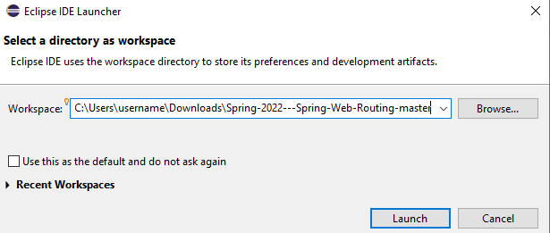

Figure 3 – Launch Eclipse Workspace

Eclipse will then launch and you will see the webrouting application on the side (Figure 4). Before proceeding, you may need to update the project’s dependencies. To do so, right-click on ***webrouting*** select ***Maven*** then choose ***Update Project*** and press ***OK*** (Figure 5). The dependencies for the project will then be downloaded and updated if necessary.

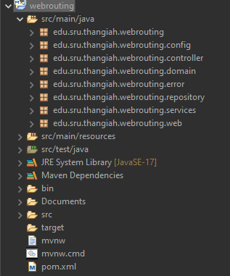

Figure 4 – Webrouting Application Inside of Eclipse

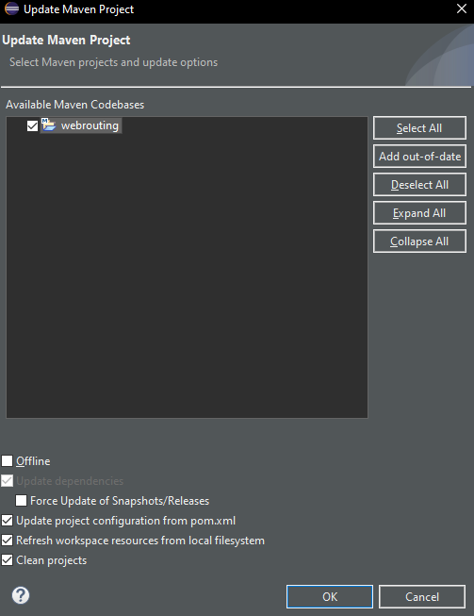

Figure 5 – Update Project Menu

## 2.2 Cloning Project into Eclipse

Another option to get the application files is to clone the GitHub repository straight into Eclipse. The method outlined in this section is specific to the Eclipse IDE and will not work for any other IDE that you may be using.

### 2.2.1 Cloning Project via URI

Start Eclipse and launch any workspace of your choosing. In the top left corner, select ***File*** then choose ***Import*** (Figure 6). From there, the ***Import*** window will open up. Choose ***Git*** and select ***Projects from Git (with smart import)*** then choose ***Next*** (Figure 7)

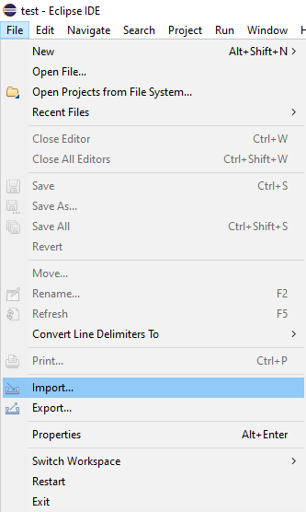

Figure 6 – Location of the *Import* Button

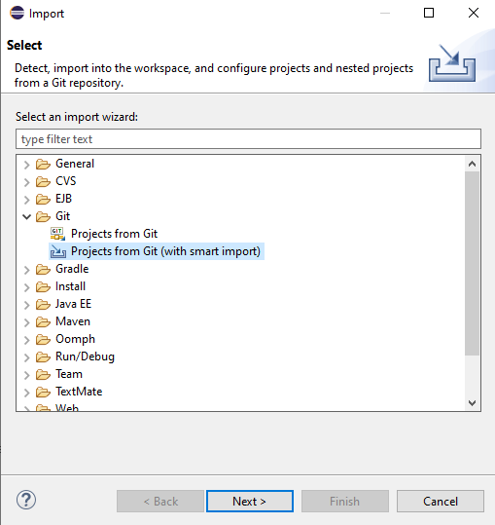

Figure 7 – Location of Git Import Button

In the ***Select Repository Source*** window, choose ***Clone URI*** then select ***Next***.

The ***Source Git Repository*** window will open and in the ***URI*** field enter this URI: ***https://github.com/samthangiah/Spring-2022---Spring-Web-Routing.git***

The ***Host*** and ***Repository path*** will automatically be filled with the correct information. The ***Protocol*** will also automatically be set to ***HTTPS***. The ***Port*** field does not need to be filled. The only fields left to be filled out are the ***User*** and ***Password***. For these, just enter your GitHub credentials. Make sure all of the information is correct then choose ***Next*** (Figure 8)

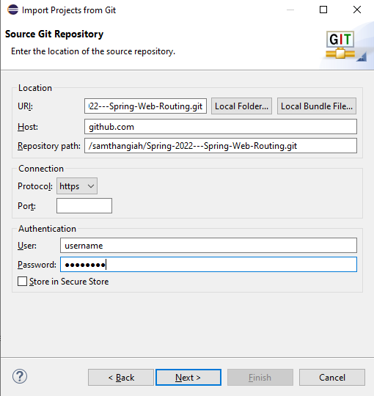

Figure 8 – Source Git Repository Menu

On the ***Branch Selection*** page, make sure all branches are selected and select ***Next*** (Figure 9)

Figure 9 – Branch Selection Page

On the ***Local Destination*** page, choose the directory that the repository clone will be saved in and select ***Next***.

The project will then be cloned to the destination. Make sure that both ***Spring-2022---Spring-Web-Routing*** AND ***Spring-2022---Spring-Web-Routing\webrouting*** are selected and choose ***Finish***

2 Projects will be added to the ***Package Explorer*** section of Eclipse. To access the application, choose the ***webrouting***. It may be a good idea to update the project. To do so, right-click on ***webrouting*** select ***Maven*** then choose ***Update Project*** and press ***OK*** (Figure 5, Section 2.1.3). The dependencies for the project will then be downloaded and updated if necessary.

# 3. Setting up the MySQL Database

Setting up a MySQL database is crucial to getting this project to work properly. Without it being setup properly, the application will not load and you will be completely unable to access the application. The following guide will show you how to install MySQL and MySQL Workbench. Of course, there are other options to do this but the overall setup should be very similar.

## 3.1 Installing MySQL & MySQL Workbench

Download the MySQL installer from <https://dev.mysql.com/downloads/>

Ensure that version 8.0.28 is downloaded.

Run the installer and when choosing a setup type, be sure to select ***Custom***

On the ***Select Products*** page, make sure to choose ***MySQL Server 8.0.28***, ***MySQL Workbench 8.0.28***, and ***MySQL Shell 8.0.28***

The next options such as ***Port***, ***Root Password***, and other settings can be set at your own discretion. For a more detailed guide on installing MySQL Server and MySQL Workbench, visit [this link.](https://www.simplilearn.com/tutorials/mysql-tutorial/mysql-workbench-installation)

## 3.2 Loading MySQL Data

To load the MySQL data, start ***MySQL Workbench*** and login with your credentials. After logging in, click ***File*** and choose ***Open SQL Script***. (Figure 10) Alternatively, you can use ***CTRL + SHIFT + O***

Choose the ***webrouting.sql*** file located in the ***Documents/*** folder of the application.

After opening, that file press the lightning bolt at the top of the screen (Figure 11)

The script will then run and the database will be successfully set up and ready to be configured in your application properties (Section 3.3)

Figure 10 – Open SQL Script



Figure 11 – Run Script Button

## 3.3 Changing Application Properties

To access the application.properties file, go to the ***src/main/resources/application.properties*** file and open it either in Eclipse or with a text editor.

Within this folder, you will want to be sure that the ***datasource url***, ***username***, and ***password*** are changed to be properly used with your MySQL Server (Figure 12).

Figure 12 – Application Properties File

Once changing the properties within this file, you should be able to successfully start the application and access the application.

# 4. Starting the Application

This section will outline how to start the application through Eclipse as well as the proper location to access the application from when it is started.

## 4.1 Where to Start Application From

Within Eclipse, navigate to ***src/main/java/edu.sru.thangiah.webrouting/WebroutingApplication.java***

Right-click on that file and choose ***Run As*** then ***Java Application*** (Figure 13).

Figure 13 – Run Webrouting Application

The application will then be started. Keep an eye on the console within Eclipse and ensure the message ***Webrouting Started!*** Is displayed before trying to properly access the application.

## 4.2 Where to Access Application From

To access the application, open up any web browser of your choice and navigate to <http://localhost:8080/>

After navigating to that page, you will be shown the ***Enterprise Routing System*** home page (Figure 14)

Figure 14 – Home Page of Enterprise Routing System

# 5. Figures

Figure 1 – Code Button 3

Figure 2 – Download ZIP Button 4

Figure 3 – Launch Eclipse Workspace 4

Figure 4 – Webrouting Application Inside of Eclipse 5

Figure 5 – Update Project Menu 5

Figure 6 – Location of the *Import* Button 6

Figure 7 – Location of Git Import Button 7

Figure 8 – Source Git Repository Menu 8

Figure 9 – Branch Selection Page 9

Figure 10 – Open SQL Script 10

Figure 11 – Run Script Button 10

Figure 12 – Application Properties File 11

Figure 13 – Run Webrouting Application 12

Figure 14 – Home Page of Enterprise Routing System 13